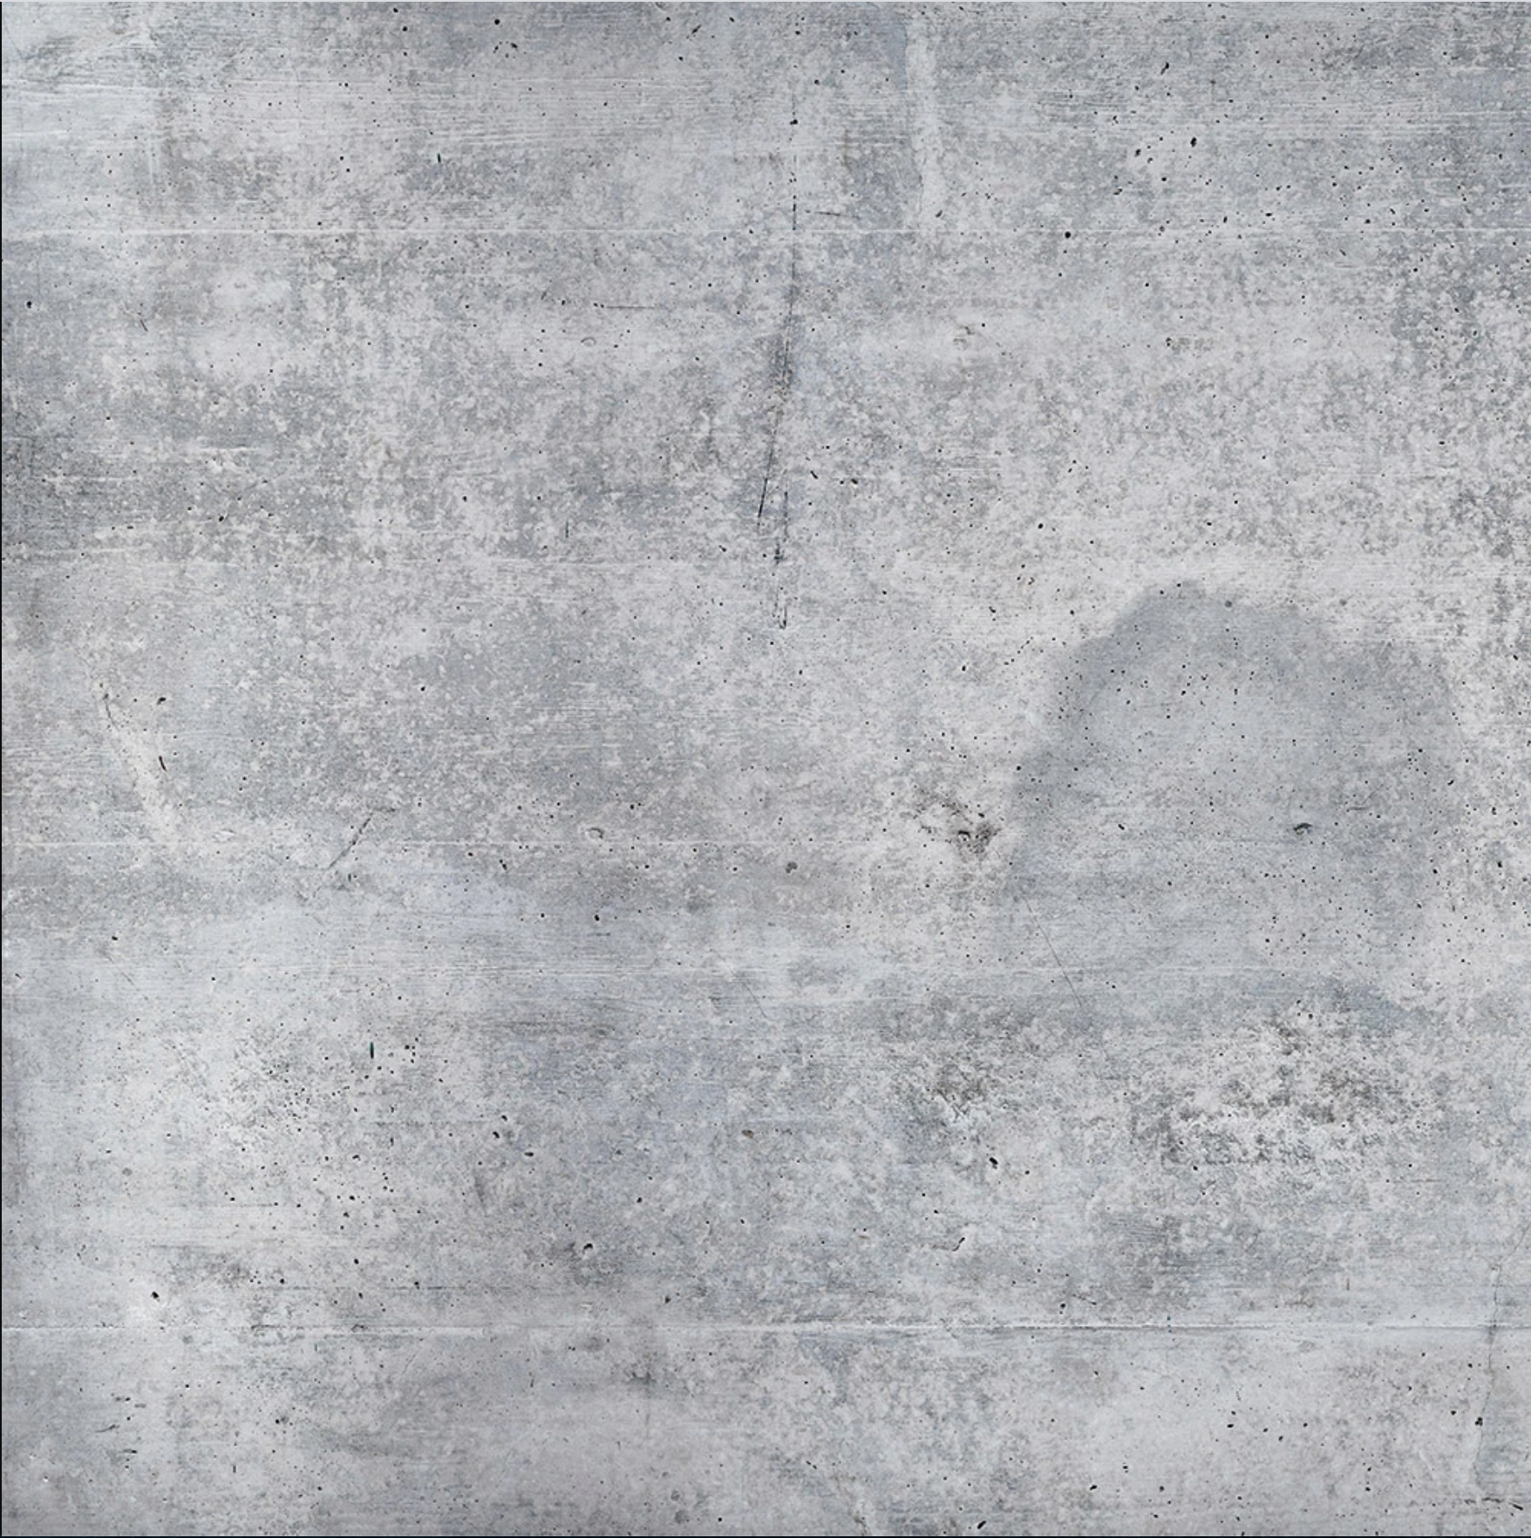

CONCEPT:

TO MAKE THE CAMERA FOLLOW THE MOVEMENT OF THE BLOCKS – AND IN THIS WAY ENABLE THE USER TO EXPERIENCE THE BUILDING FROM DIFFERENT PERSPECTIVES.

GITHUB:

PROGRAM:

MADE BY_

ESTER MARIE AAGAARD

RIGHT

LEFT

DOWN

UP

CAMERA MOVEMENT

SPACE – NEW BUILDING

A

Z

CAMERA TILT

R

D

F

G

MOVE BUILDING BLOCK

J

K

CHANGE FLOOR

INSTRUCTIONS:

HOUSE BLOCKS

(NOW WITH CAMERA)

A